Studies of Black Sea macro– and mesoscale circulation with application
of SVP and SVP-B drifters. Present results and future plans

V.N.Eremeev*, E.Horton**, S. V. Motyzhev*, P.- M. Poulain***, S. G. Poyarkov****,
Yu. B. Ratner*, D. M. Soloviev*, S.V. Stanichny*, A.G.Zatsepin****,

* Marine Hydrophysical Institute, 99011, Kapitanskaya, 2, Sevastopol, Ukraine
**Naval Oceanographic Office, 1002 Balch Boulevard, Stennis Space Center,
MS 39522-5001, USA
*** Department of Oceanography, Naval Postgraduate School, Monterey, CA 93943-5000
**** P. P. Shirshov Institute of Oceanology, 117997, Nakhimovsky, 36, Moscow, Russia

Introduction
Rapid environmental degradation of the Black Sea ecosystem that occurred in response to the anthropogenic impact, results from limited water exchange with other basins, weak vertical mixing due to the existing strong density stratification and enhanced pollution caused by contaminated river discharge, city and tourist resorts wastes, oil spills and spills of other contaminants from ships and oil terminals. Because most of the contaminants are coming from land based sources the investigation of processes that maintain horizontal mixing and shelf – open sea exchange are of paramount importance. However, these processes are still poorly understood.
A typically accepted scheme of large scale Black Sea circulation based on the analysis of hydrographic data assumes that the circulation pattern consists of a persistent cyclonic gyre formed by the Rim Current confined to the continental slope and two (eastern and western relative to the Crimea peninsula) or three embedded cyclonic sub-gyres The flow separates the shelf region from the central part of the sea. According to that scheme (Fig.1a), based on hydrographic ship-borne data, only very limited horizontal mixing may occur.
On the contrary, satellite infrared and color images of the Black Sea provide evidence of high mesoscale eddy activity in the whole Black Sea area, including the Rim Current zone that, probably, is a source of energy for such variability (Fig.1b). Satellite data show that circulation in the surface layers of the Black Sea and associated physical and biological processes are more complicated than that expected from the geostrophic motions alone. The concentration of various admixtures and supply of nutrients to the euphotic layer from below are determined by horizontal and vertical water eddy structures such as vortices, vortex dipoles and multipoles, filaments and jets. These structures penetrate across the Rim Current zone and maintain the exchange between the shelf region and central part of the sea. So, it is possible to speculate that the Rim Current is not persistent in space and time and that most of water parcels are not only involved in a closed large-scale cyclonic circulation but also have complicated trajectories of motion. One of the best ways to check this assumption is to study real trajectories of water parcels in the upper mixed layer with the usage of Argos tracked Lagrangian drifters. Among various observational platforms drifting buoys are of special interest and importance as they are capable of providing near-real-time information on the state of the sea at a relatively low cost.

Black Sea drifting buoy experiments in 1999 – 2001.
In September 1999 six such drifters were launched in the northeastern Black Sea in order to study the surface water dynamics with main focus on the mesoscale circulation features. The Black Sea’99 drifter experiment (Motyzhev S., 2000)was organized as a part of a multi-disciplinary study of the Black Sea ecosystem and of the shelf – deep basin interactions conducted by Russian oceanographers from P. P. Shirshov Institute of Oceanology, Russian Academy of Sciences (Moscow) on the R/V “Akvanavt” in collaboration with specialists from other Russian Institutes and Universities and with Ukrainian scientists, particularly, from the Marine Hydrophysical Institute of National Academy of Sciences of Ukraine (MHI NASU, Sebastopol). The main strategy of the Black Sea’99 expedition was based on the joint application of satellite imagery, Argos-tracked drifters and hydrographic, chemical and biological surveys of selected mesoscale structures. This strategy has never been used in Black Sea studies. It made possible to obtain innovative results on the mesoscale dynamics and its role in the ecosystem functioning and pollution transport in the northeastern part of the Black Sea.
The analysis of satellite SST images in August-September 1999 revealed the existence of an unusual anticyclonic circulation feature in the center of the eastern part of the sea. This anticyclonic eddy (A1) formed a large vortex pair (about 150 km in the cross section) with a cyclonic eddy (C1) located to the north of it and closer to the Rim Current (Fig. 2). It was decided to focus the investigation efforts of the Black Sea 99 expedition on this vortex pair. During the survey of R/V “Akvanavt” in the end of September 1999, the multi-disciplinary study of this eddy structure and adjacent areas was carried out and 6 SVP drifters were deployed into and near the vortex pair. During the first four days after deployment, all of them were successfully tracked by the Argos satellite system. Drifter trajectories revealed well the current system, associated with the vortex pair and the orbital velocity of eddies was determined on the base of drifter data. Approximately the same velocity magnitudes in the vortex pair were calculated using the hydrographic data (geostrophic approach).
After 4 days from the deployment date, two drifters failed to transmit for some unknown reason. The remaining four drifters were tracked by Argos (3 – 7 times during a day) until the end of the year 1999. They revealed very complicated trajectories (Fig 3a). As we can see from this figure one of the drifters that was deployed near the center of the anticyclonic part of the vortex pair was trapped by the eddy for more than 2 months. The other three drifters basically followed the cyclonic path of the macroscale circulation, but they revealed much of mesoscale variability of movements associated with eddies, particularly, in the region near the Crimean peninsula. However, it is most remarkable, that their trajectories did not show the existence of the western cyclonic gyre. Just after passing the Crimean peninsula the drifters were deflected southward from the coast and all of them reached the center of the western part of the sea. Surprisingly, central western Black Sea, like the central eastern region, was an area of high eddy dynamics. Finally all drifters except one left both centers of the eastern and western basins. Unfortunately 3 from 4 drifters were automatically switched of at the end of the year 1999.
The Black Sea drifter experiment was continued in the fall of 2000. During this time the satellite images did not show any well-pronounced mesoscale eddies in the north-eastern and central parts of the sea, but they were still observed near the Crimea. So, four SVP-B drifters were deployed in the beginning of October in the region to the south of the Crimea (Fig. 3b). Contrary to drifters’99 that moved to the south after passing the Crimean peninsula, drifters’00 were transported by currents to the north-west direction and three of them moved deep into the wide shelf zone. One of those three soon failed to transmit and others two after some time turned to the south-west and than moved generally following the direction of the depth contour and coastal line. The same did the last of the drifters’00 that was not transported initially into the shelf zone: it moved south-west along the continental slope following the typical path of the Rim Current (Fig. 3b). Unfortunately, soon after the deployment Argos tracking of the drifters’00 became very rare (once during few days, as typical) due to the defect of transmitters. So it was impossible to reveal definitely the mesoscale features and to calculate any Lagrangian statistical characteristics of their movements as it was done before on the base of the drfters’99 data.
One of the most striking questions concerns the physical nature of the difference in macroscale circulation that was revealed by the drifter trajectories in 1999 and 2000. To solve this question the combined analysis of space-time structure and variability of wind field above the Black Sea and of macro- and mesoscale water circulation patterns in its upper layer indicated by drifters in 1999-2000 was fulfilled. It was determined that the Black Sea upper layer circulation pattern considerably depend on the level and space characteristics of the wind stress vorticity, or wind Ekman pumping and its seasonal and interannual variability. This result is well illustrated by Figs. 3a,b where the drifter trajectories are superimposed at the maps of wind Ekman pumping velocity W_{ek} in the Black Sea. It is observed from these figures, that the drifter trajectories generally follow the isolines of W_{ek}. Indeed, in the fall of 1999 the drifters were deployed in the area of the cyclonic wind stress vorticity (positive values of W_{ek}) that reached the central part of the sea. Following the counters of W_{ek} = const drifters’99 were deflected to the south just after passing the Crimea peninsula (Fig. 3a). In the fall of 2000 the wind stress vorticity was anticyclonic above the Crimean peninsula (negative values of W_{ek}) and that seemed to be a reason why most of the drifters’00 initially moved to the north-west direction (Fig.3b). So it may be suspected that the variability of the Black Sea macroscale circulation pattern is basically determined by the variability of the vorticity of the wind stress upon the sea surface.

The summary of preliminary results.
In 1999 and 2000, the Marlin SVP and SVP-B drifters (6 and 4, correspondingly) were used to study macro –and mesoscale Black Sea circulation together with the application of satellite imagery and CTD surveys.
The preliminary results of these pilot drifter experiments have shown that:
- Joint application of satellite imagery, Argos tracked SVP drifters and a hydrographic survey is a powerful strategy for a multidisciplinary investigation of selected mesoscale dynamical structures. This strategy is up-to-date and has been never used before in Black Sea research.
- In summer – autumn seasons of 1999, the mesoscale dynamics was active not only in the near-shore and Rim Current regions but in the central parts of the Black Sea also. It contained long-live coherent structures (like an anticyclone in the center of the eastern part of the sea with an adjoining cyclone), so the mesoscale field was not chaotic, but well organized and, thus, contributing to large-scale dynamics.
- Contrary to the results of 1999, observations carried out in summer - autumn seasons of 2000 have shown very low level of mesoscale variability in the northeastern and central parts of the Black Sea. However, the Caucasian part of the Rim Current and the eastern circulation gyre were quite energetic and well-pronounced features.
- Drifter trajectories demonstrated that large-scale currents in the BS are not much contour - like as was usually stated before. Evidently, the western gyre did not exist in the fall of 1999, so the drifters were able to cross the western part of the sea just across its center. In autumn of 2000, four drifters deployed to the south of Crimea migrated in the northwest direction and penetrated far on the shallow northwestern shelf.
- The combined analysis of drifter trajectories and of space-time structure and variability of the wind field over the Black Sea have shown that drifters mostly follow isolines of wind stress curl observed a month earlier.
- The potential vorticity gradient induced by steep topography was not an unpenetrable barrier for shelf - deep basin interactions and water exchange and pollution transport. The mesoscale eddy dynamics seem to be a major factor of the shelf-deep basin interactions in the Black Sea.

3. Plans for 2001 - 2002
Just after the end of the pilot Black Sea drifter experiments of 1999 – 2000, it became clear that in order to move further it is very important to organize in the nearest future a macroscale drifter experiment (a simultaneous deployment of 30 – 40 drifters in different parts of the Black Sea and tracking them during one year) as part of Black Sea GOOS activities. The experiment is thus part of the work carried out by the Black Sea riparian countries in order to design, create and maintain a regional operational multipurpose and versatile observation network that would serve as a basis for the studies of Black Sea macro- and mesoscale dynamics and environmental operational forecasting. Such possibility now became real due to the considerable input from Naval Oceanographic Office (NAVOCEANO).
The Ukraine, Russia and USA are going together to deploy in the Black Sea during the fall of 2001and spring of 2002 about 40 oceanographic Argos tracked drifting buoys, in particular 14 Marline SVP-B drifters and 25 XAN-3 drifters (with thermistor chains). Part of the drifters (6 Marlin SVP-B drifters) will be deployed in the northeastern part of the basin by a Russian research vessel. The main goals of the research are to study macro–and mesoscale Black Sea circulation and to provide vital data for operational hydrometeorology, in particular for weather forecasting. The EuroGOOS has a large interest in the latter aspect of the experiment and it is ready to support the research in the future.

The specific objectives of this experiment are:
- To provide the meteorological and weather monitoring over the area of the Black Sea on the basis of SVP-B drifter data.
- To study largescale and mesoscale structure of the upper layer currents and their seasonal variability and the dependence on atmospheric forcing on the base of SVP and SVP-B drifter data.
- To assess more statistically approved estimates of lateral eddy diffusivity K (P.- M. Poulain, 2001)in the Black Sea upper layer and to estimate lateral fluxes of different admixtures and pollutants.
- To carry on estimations of the Lagrangian length scale L in the Black Sea and to compare it with the internal Rossby radius Ro.
- To check the parameterization of lateral diffusivity of the form K=σ Ro , where σ - is r.m.s. of the Lagrangian velocity fluctuations.
- To study the seasonal cycle of the Black Sea vertical temperature profile evolution (winter cooling, summer heating) and to investigate the process of Cold Intermediate Layer (CIL) formation on the basis of XAN – 3 drifter data.

Start of the new experiment .
At the fall of the 2001 drifters were deployed in the two clusters :
first - 4 SVP + 6SVP-B drifters at 22 of October in the Russian sector of the Black Sea, second - 8 SVP-B +10XAN-3 drifters at 19-23 of December in the Ukrainian sector of the Black Sea. Tracks of the drifters for January 4 shown on fig 4.
Four drifters from the first cluster were loosed before January 2002 due to vandalism of fishermen and stopping transmitting. Three drifters after passing the Crimea peninsula turned to the south similar to experiment 1999 year . But area of the positive W_{ek} (cyclonic vorticity), shown on fig 5., hadn't the same form as in 1999 and three drifters followed by traditional circulation scheme. So, wind condition may significantly change current circulation scheme of the Black Sea.
Second clusters drifters deployed by pairs SVP-B + XAN-3 ( 4 XAN-3 drifters was out of operation after deployment). Anomaly cold December did not give possibility to study generation of the winter convection - at December 23 al 50-meters layer was uniformly mixed and had temperature in the central part 7.66° C. During two weeks temperature dropped to 7.1°C. This fact will lead to the filling of the CIL during 2002 year winter convection period. Typical temperature for January last years was ~8.5°C, and CIL loosed waters.
It is anticipated that, besides realization of the specified scientific tasks, the experiment will provide useful information for several Modules of Black Sea GOOS, in particular, for (i) the Climate Module through the description of physical processes that determine Black Sea circulation and climate change in the region as well as provision of the observational data needed for the prediction of climate variability and climate change; (ii) the Coastal Module through the description of shelf-deep sea exchange processes, and (iii) the Service Module by providing meteorological data, which could not be acquired otherwise, for the development of a large range of marine meteorological and oceanographic services in support of shipping, fisheries, coastal zone management, tourism and recreation, and improving the safety of life at sea.
Data from the drifters will be made available on-line free of charge for all of the Participants of the Program and will be used for better description and understanding of physical processes in the Black Sea and their mesoscale variability. The results of drifter data analysis will be published in peer review joint papers.

References
- V. Motyzhev, P.- M. Poulain, A. G. Zatsepin, C. Fayos, A. G. Kostianoy, N.A. Maximenko, S. G. Poyarkov, D. M. Soloviev and S.V. Stanichny., 2000, New phase of drifter experiment in the Black Sea. Developments in moored and drifting buoy designs, programmes, sensors and communiocations. - Unesco DBCP Technical Technical Document Series, No. 17-2000-P. 116-128.

P.- M. Poulain, 2001,Adriatic Sea circulation as derived from drifter data between 1990 and 1999,Jornal of Marine Systems, vol 29, pp3-32.

Ovchinnikov,I.M., and Titov V.B., 1990, Anticyclonic vorticity of currents in the Black Sea costal zone, Doklady Akad.Sci., 314, 1236-1239, (in Russian)
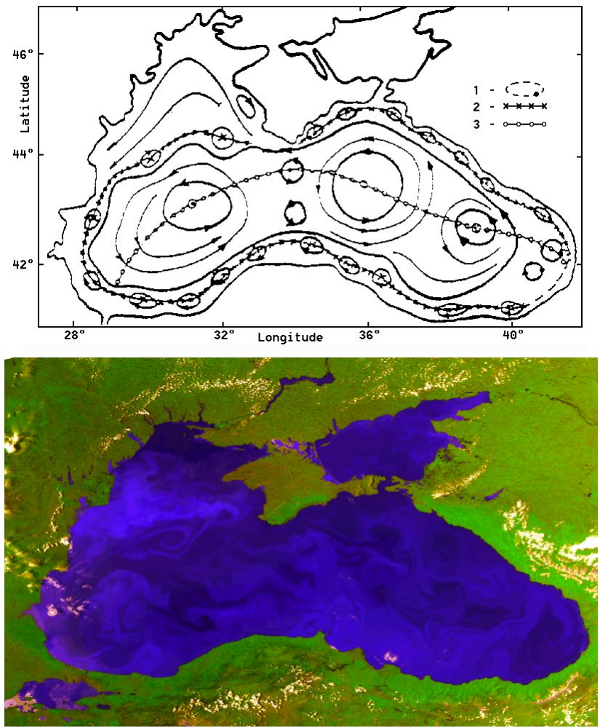
A
B

Fig. 1a. Traditional scheme of Black Sea upper layer circulation (Ovchinnikov, Titov, 1990).
Fig. 1b. AVHRR image of the Black Sea (23 of June, 1993).

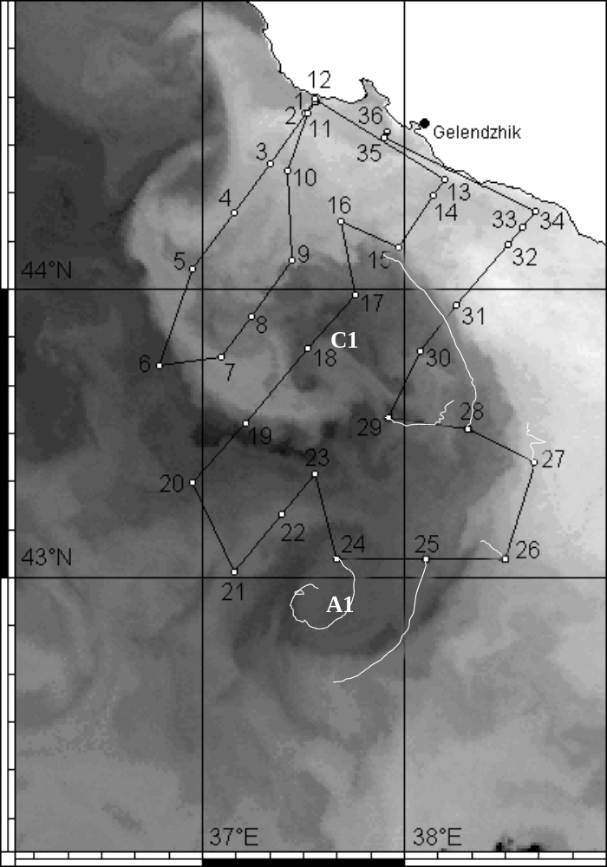

Fig. 2. IR image of the north-eastern part of the Black Sea (light color – warm water, dark color – cold water) of 29 September, 1999 with a set of stations and sections of the R/V “Akvanavt” survey (25 –30 of September, 1999), marked positions of the eddies (A1, C1) in the vortex pair and drifter trajectories (light curves) for 4 days after deployment.

Fig. 3. The trajectories of drifter movements superimposed on the maps of wind Ekman pumping velocity W_{ek} (m/s, ×10⁶) over the Black Sea area:
North latitude
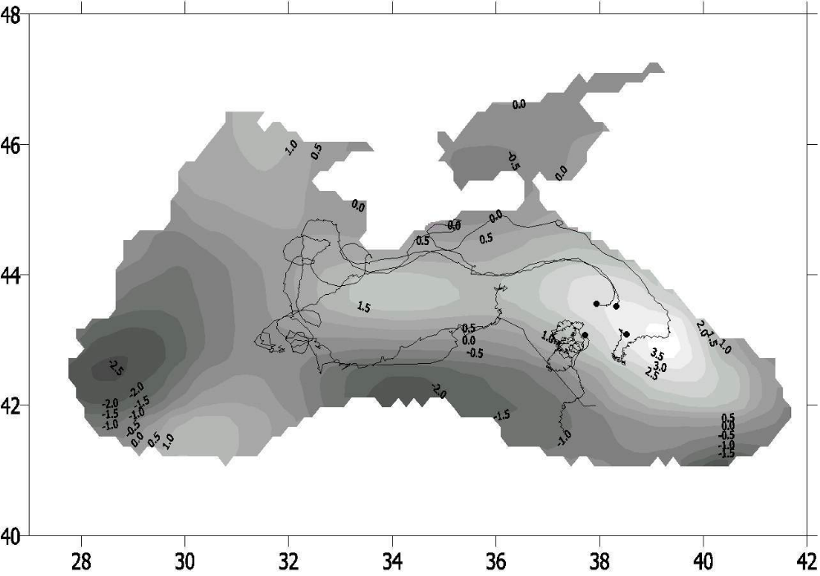

East longitude
North latitude
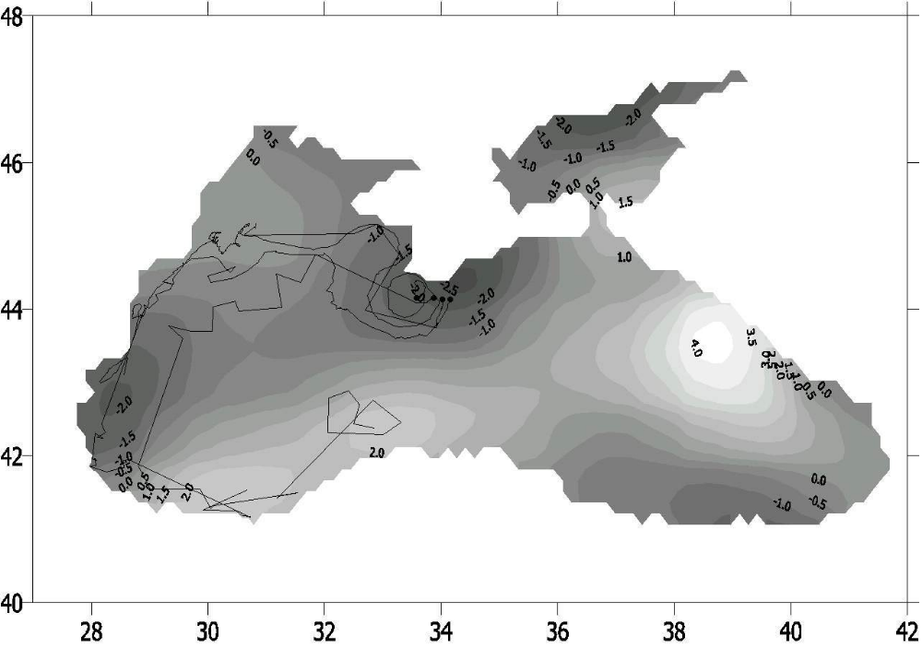
b)

East longitude
а)
- October – December 1999;
- October – December 2000.

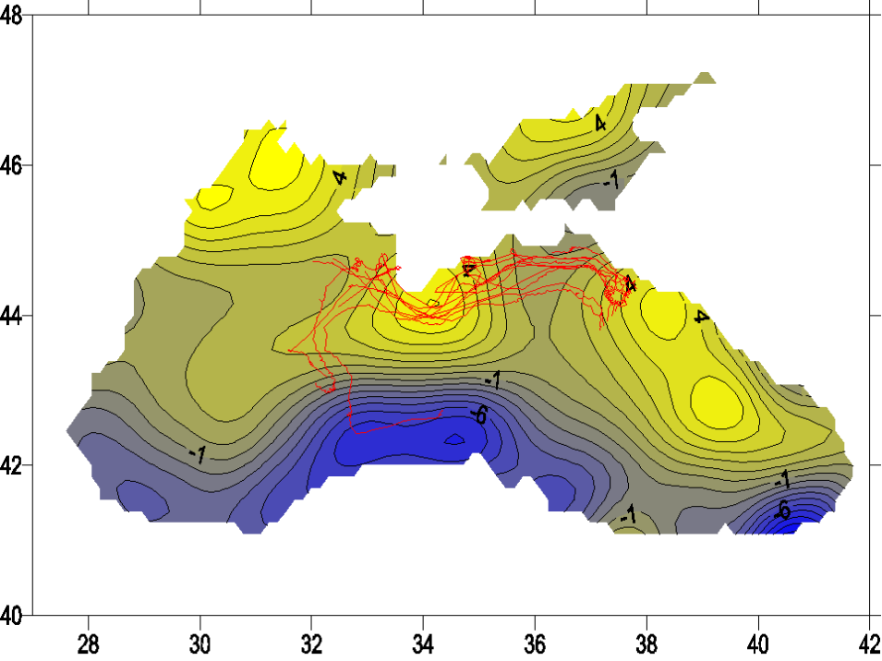

Fig. 4. The trajectories of drifter movements :
SVP-B first cluster - red lines, SVP first cluster - blue lines
SVP-B second cluster - black lines, XAN-3 second cluster - green lines
FFig.5. The trajectories of drifter movements (October 22 - November18) superimposed on the maps of wind Ekman pumping velocity W_{ek} (m/s, ´10⁶) over the Black Sea area for 4-18 November 2001

